How to Use This Toolkit:
1. Reflect & Share: Think about a time you carried the round for someone, or when someone carried the round for you. Share stories on social media and use the hashtag #CarryTheRound.
2. Highlight Resources: Share information like WAV’s resources on secure gun storage laws in your state. Encourage safe storage to increase safety and provide those crucial moments.
Use the sample posts in this toolkit as a starting point!
Link to Carry the Round kit: https://aerialresupplycoffee.com/products/worried-about-a-veteran-wav-kit
Nearly ¾ of Veteran suicides are by gun. Worried About a Veteran helps you start conversations to create time and space between thoughts of suicide and immediate access to a gun. Why not have those conversations over coffee?
To kickstart the conversation, experience the first-ever Carry the Round Kit, in collaboration with @aerialresupplycoffee and @stopboxusa: [ARC coffee link]
And get tips for starting the conversation at WorriedAboutaVeteran.org. #CARRYTHEROUND
Why not have a lifesaving conversation over a cup of coffee?
The “Carry the Round” kit is the first of its kind: a limited-edition coffee packaged inside of an innovative firearm storage solution, created specifically to inspire conversations on secure storage practices.
Experience the Carry the Round Kit, in collaboration with @aerialresupplycoffee and @stopboxusa: [ARC coffee link]
And get tips for starting the conversation at WorriedAboutaVeteran.org. #CARRYTHEROUND
Nearly 3/4 of Veteran suicides involve a gun. Secure storage saves lives by creating the critical time and space needed in a moment of crisis.
Be part of the solution. Visit WorriedAboutaVeteran.org. #CARRYTHEROUND
We all want to protect the ones we love, but sometimes, we don’t know where to start. That’s why Worried about a Veteran has all the tools you need to start a conversation. Together, we can make a difference.
🔹 Explore life-saving tools and strategies at WorriedAboutaVeteran.org #CARRYTHEROUND
Did you know there are options for storing a loved one’s gun when they’re going through a tough time?
Equip yourself with the knowledge to support the Veterans in your life: WorriedAboutaVeteran.org #CARRYTHEROUND
When it comes to preventing gun suicide, we can all make a difference. Worried About a Veteran offers:
🔹 Guidance on how to start important conversations
🔹 Tools to help during times of stress
🔹 Legal info on secure gun storage options in all 50 states
🔹 Stories from others who’ve been there
No matter where you are in the journey, WAV has something to help.
Explore the tools at WorriedAboutaVeteran.org and share with your loved ones. #CARRYTHEROUND
Carry the round of ammo for your loved one. Carry the round of conversation.
Carry it together. Your journey starts now. #CARRYTHEROUND
Together, we can prevent gun suicides. Visit WorriedAboutaVeteran.org to start the conversation.
Worried about your Veteran? The WAV website has:
🔹 Guidance on how to start important conversations
🔹 Tools to help during times of stress
🔹 Legal info on secure gun storage options in all 50 states
🔹 Stories from others who’ve been there
Find these and more at WorriedAboutaVeteran.org. #CARRYTHEROUND

SOCIAL MEDIA GRAPHICS:
X: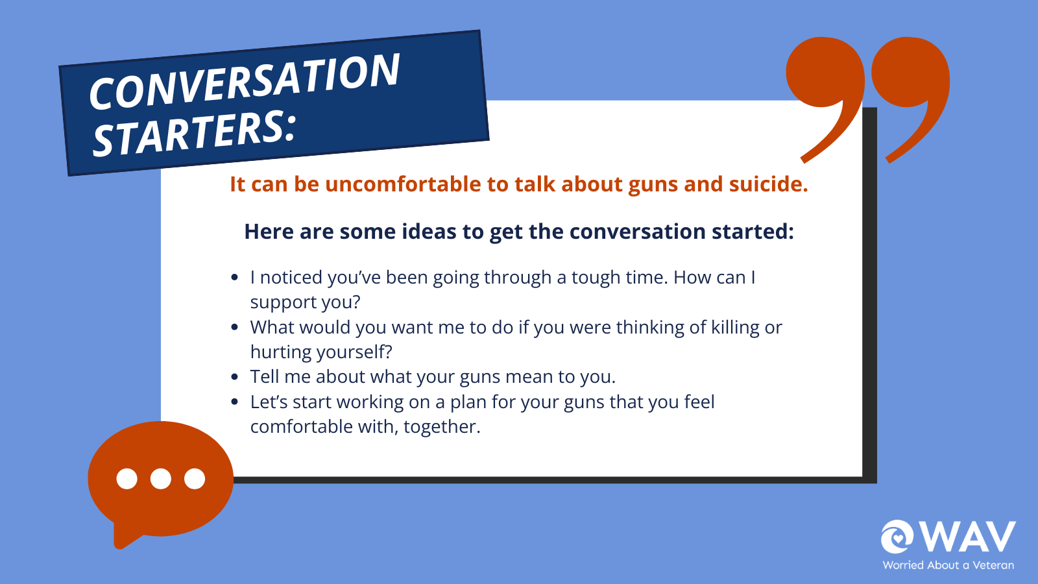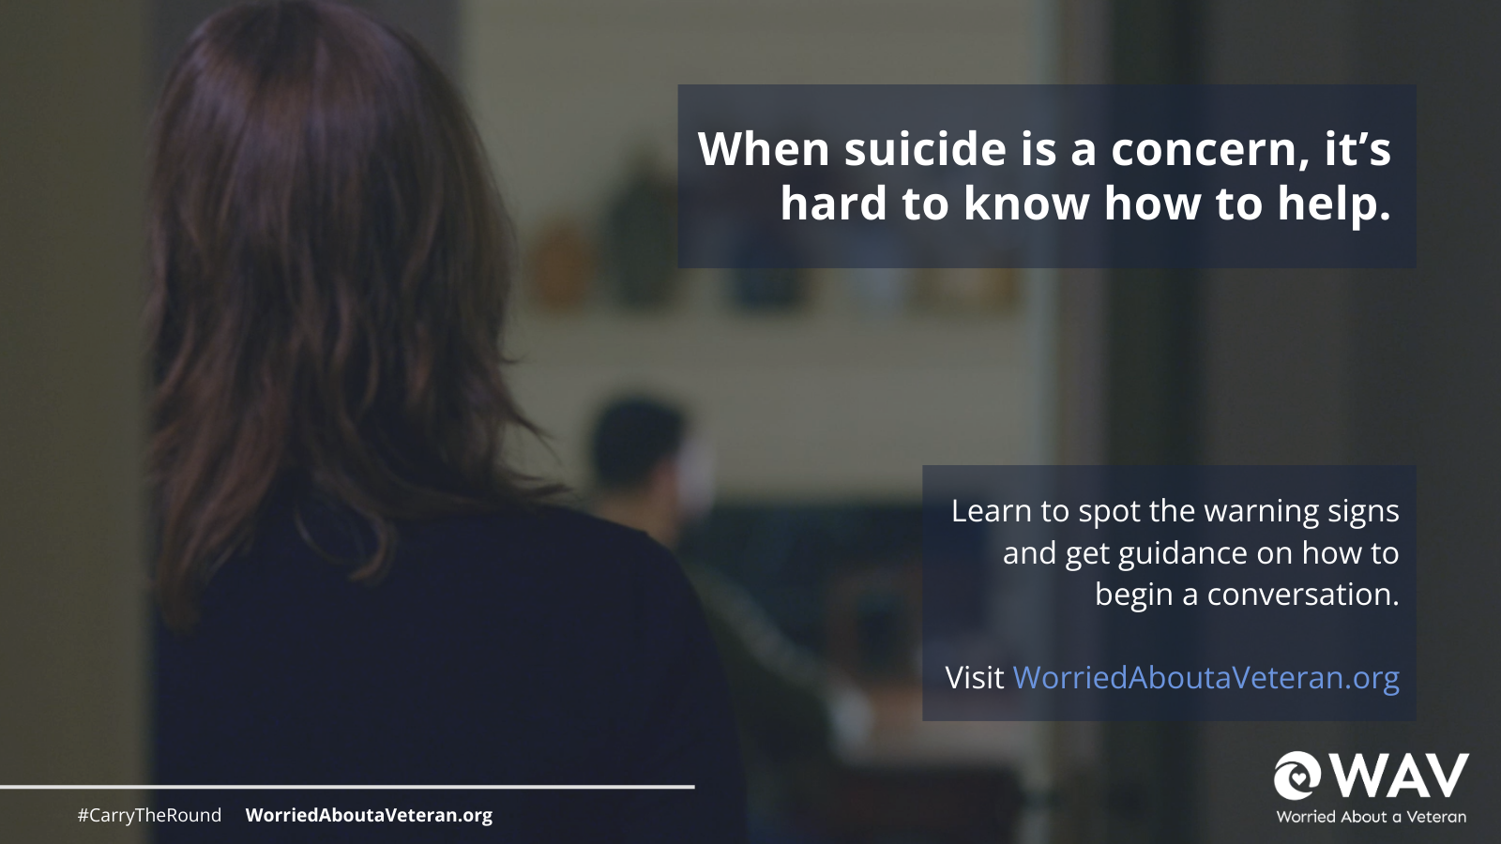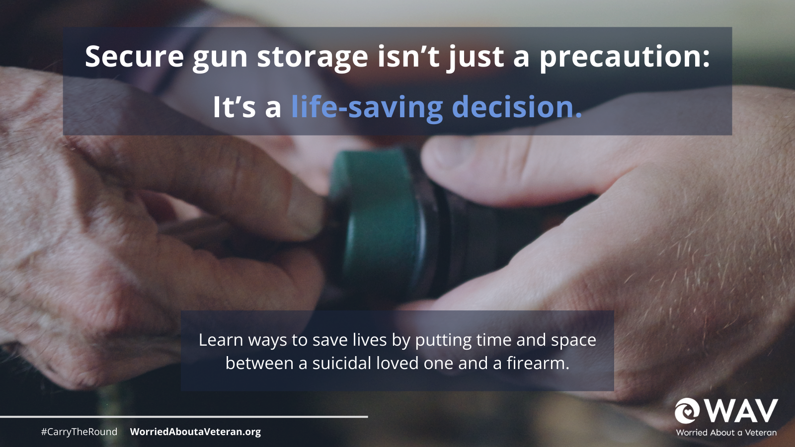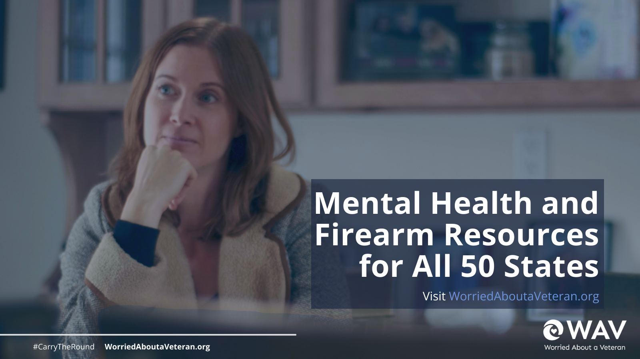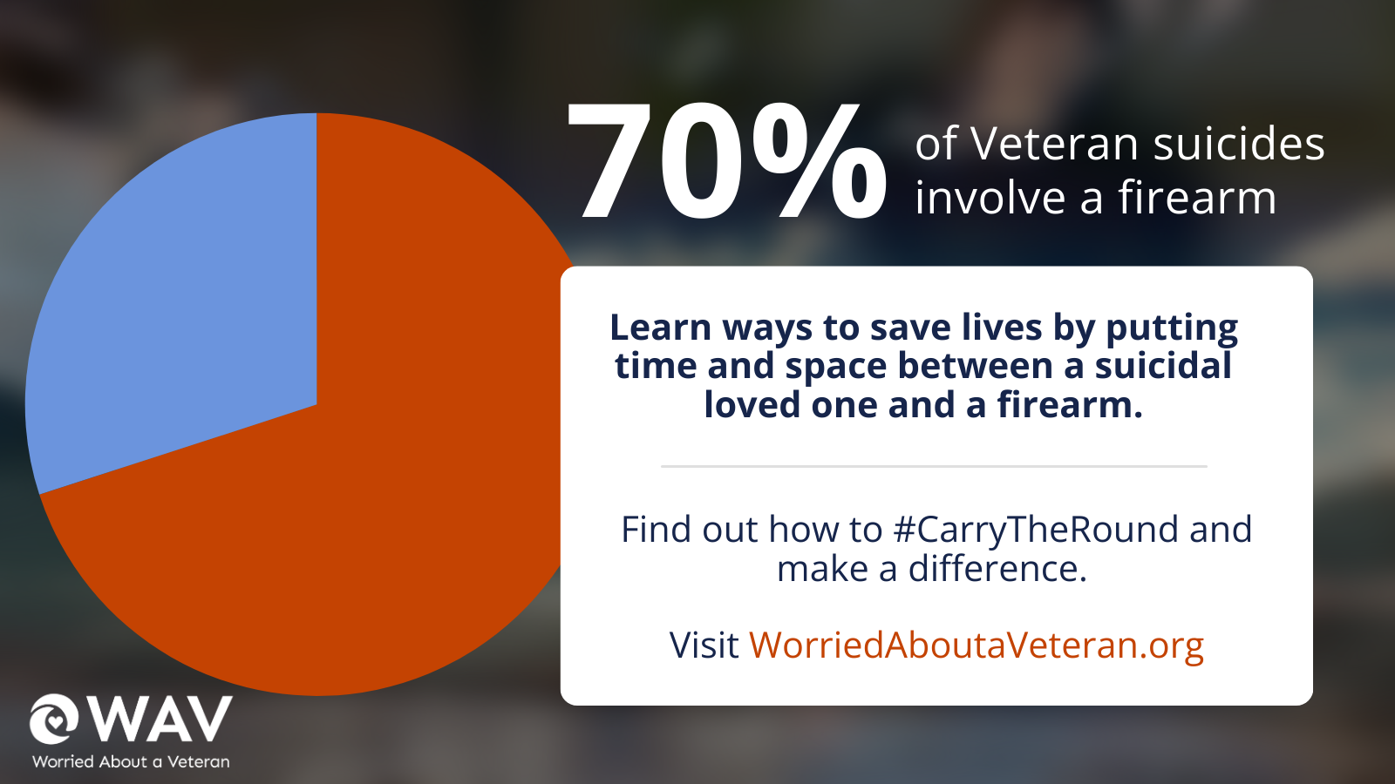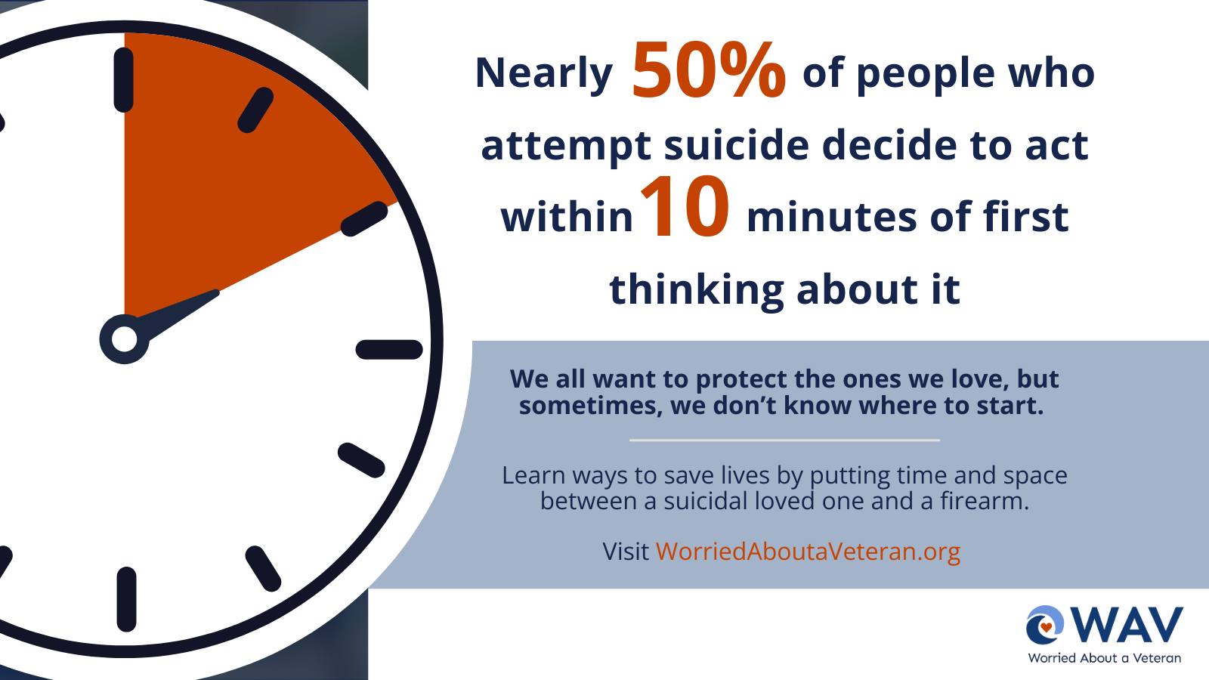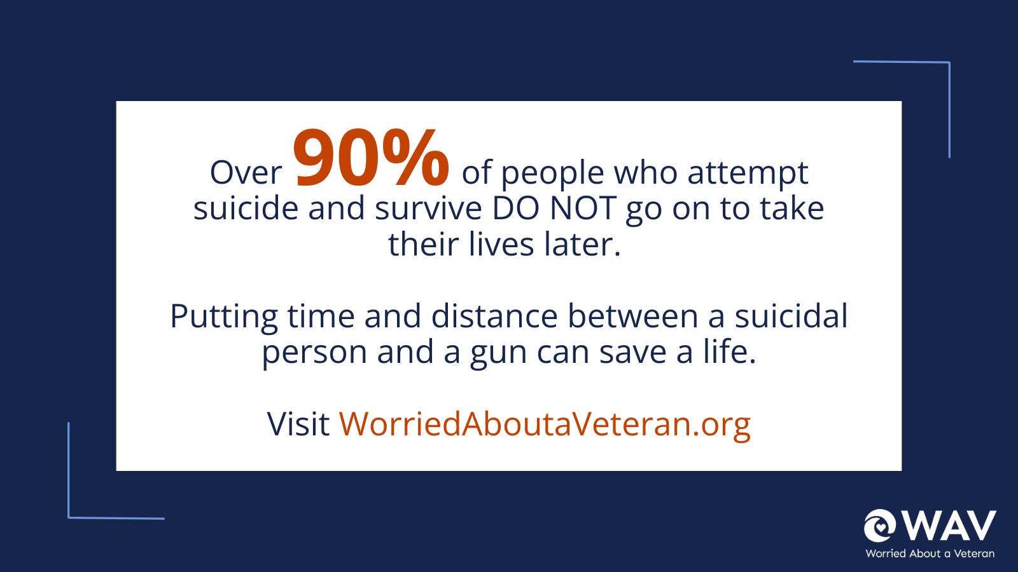

Facebook: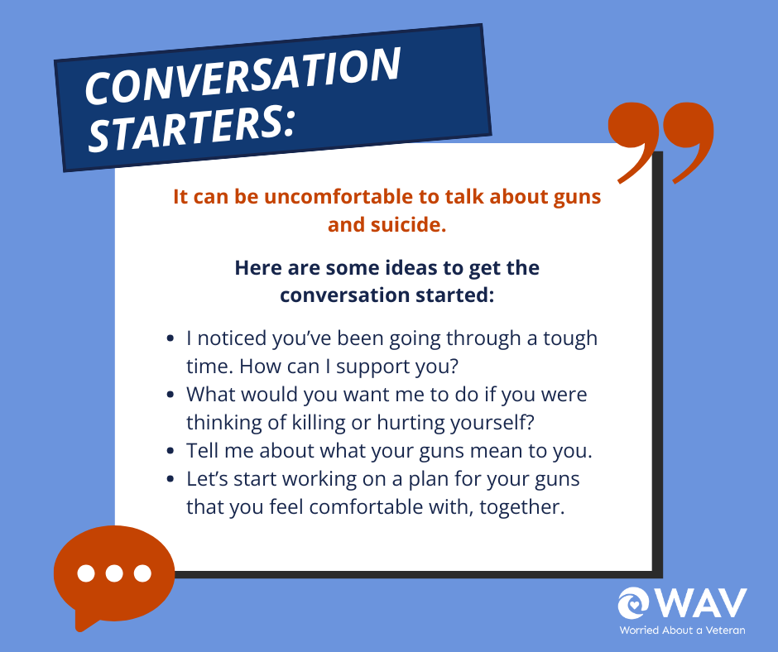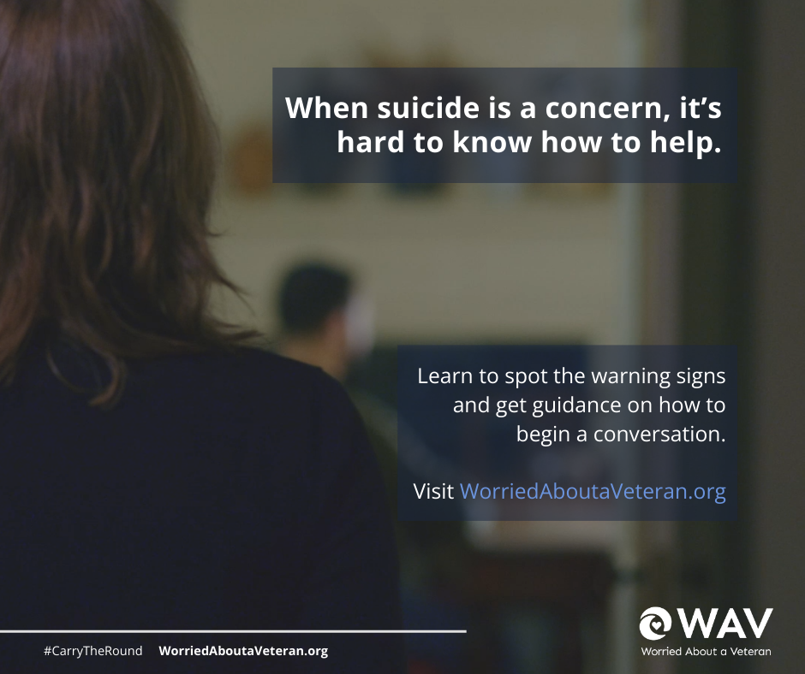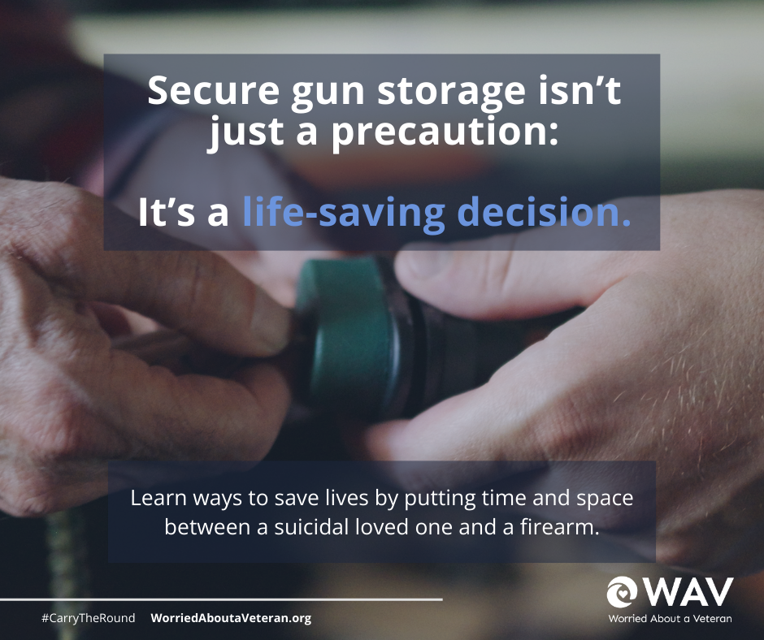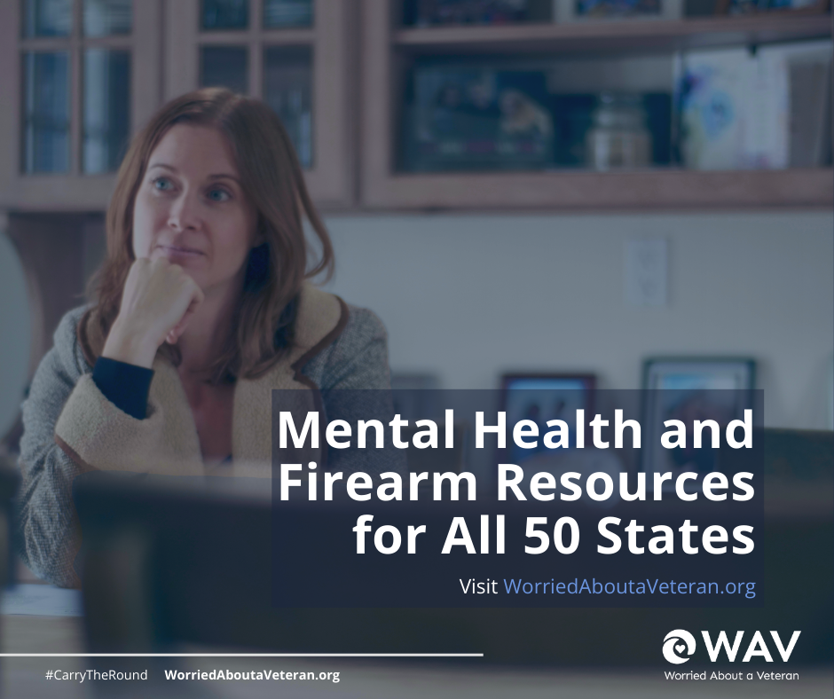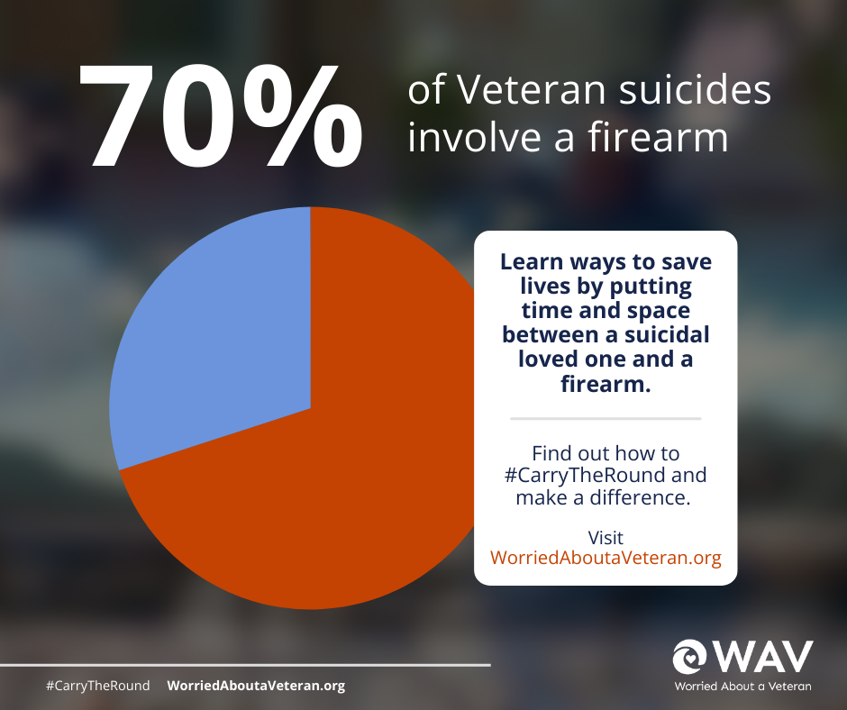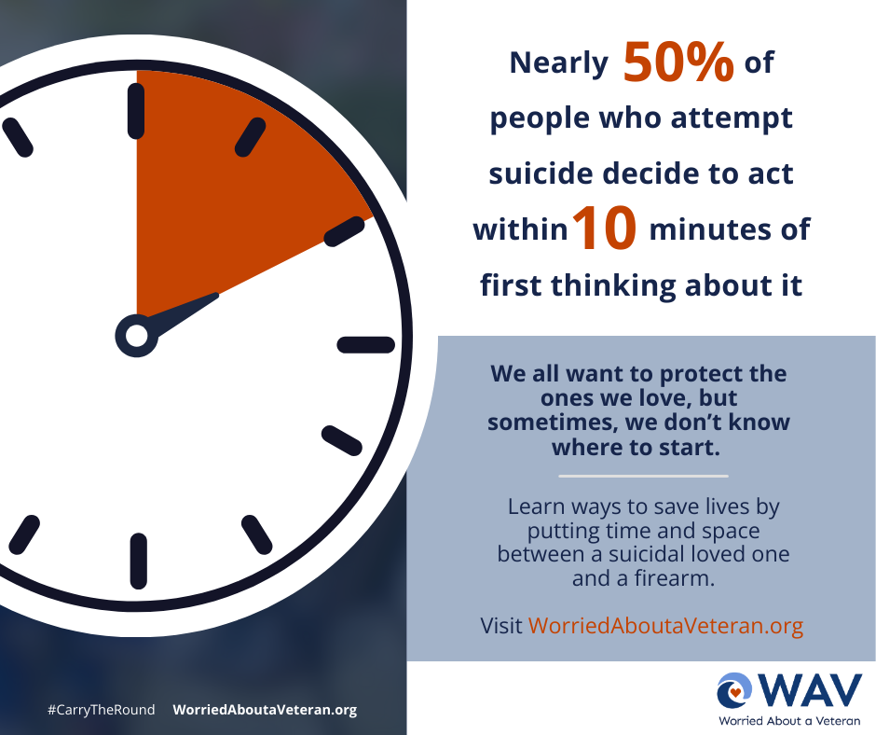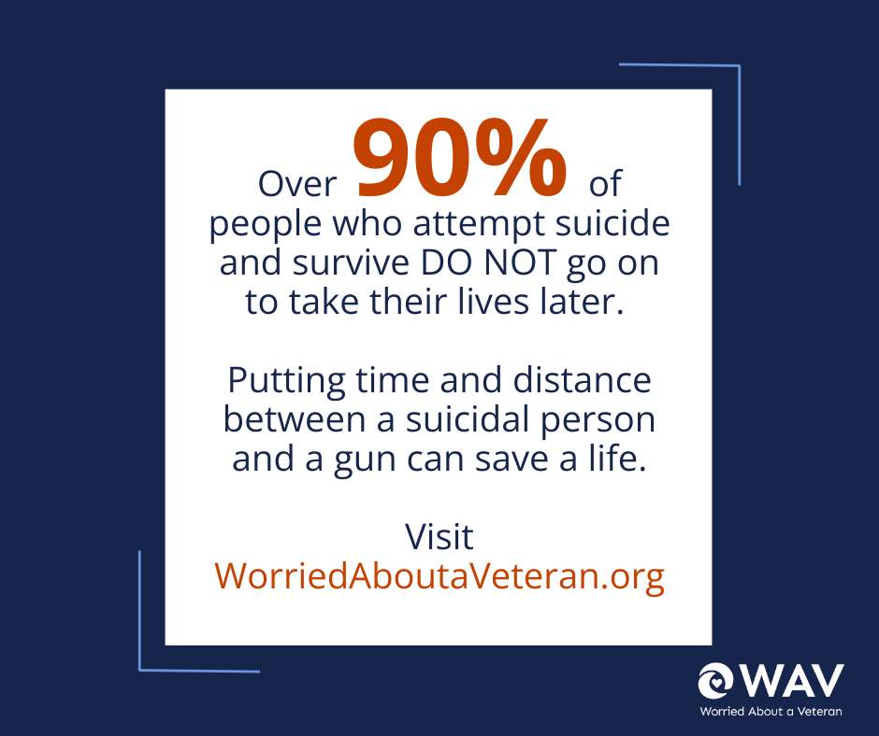

Instagram Post: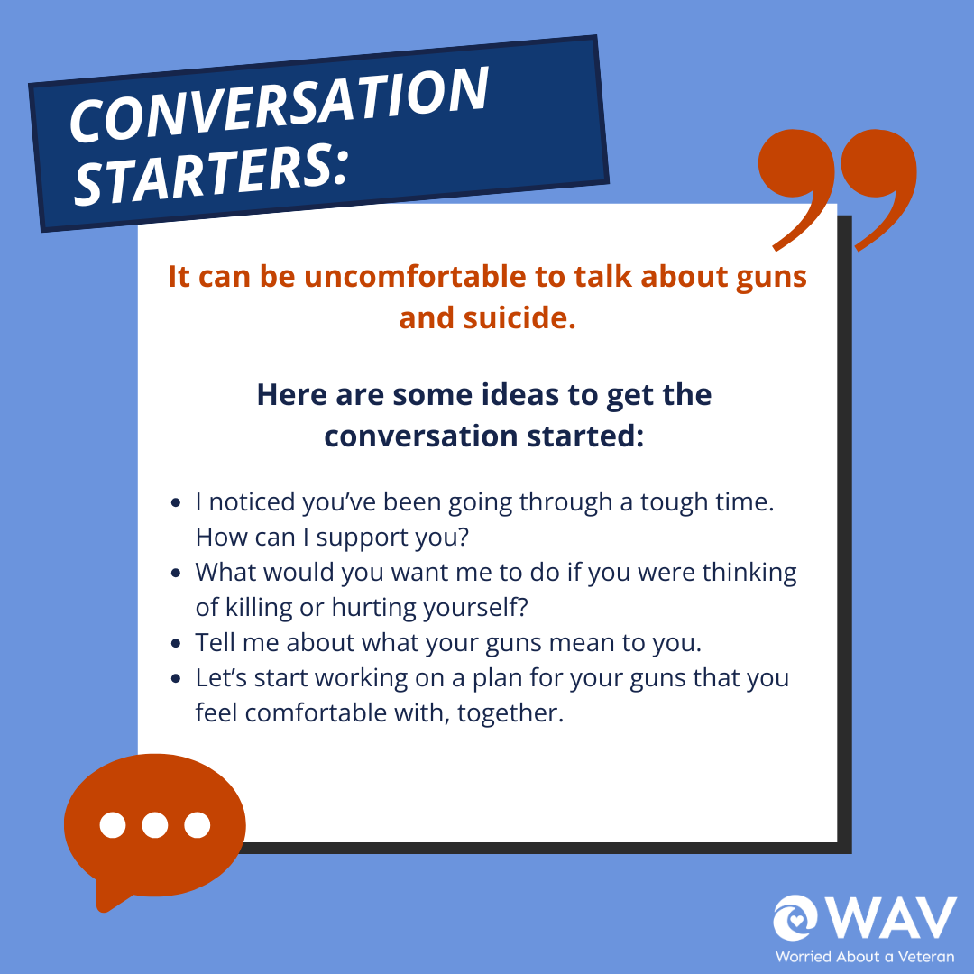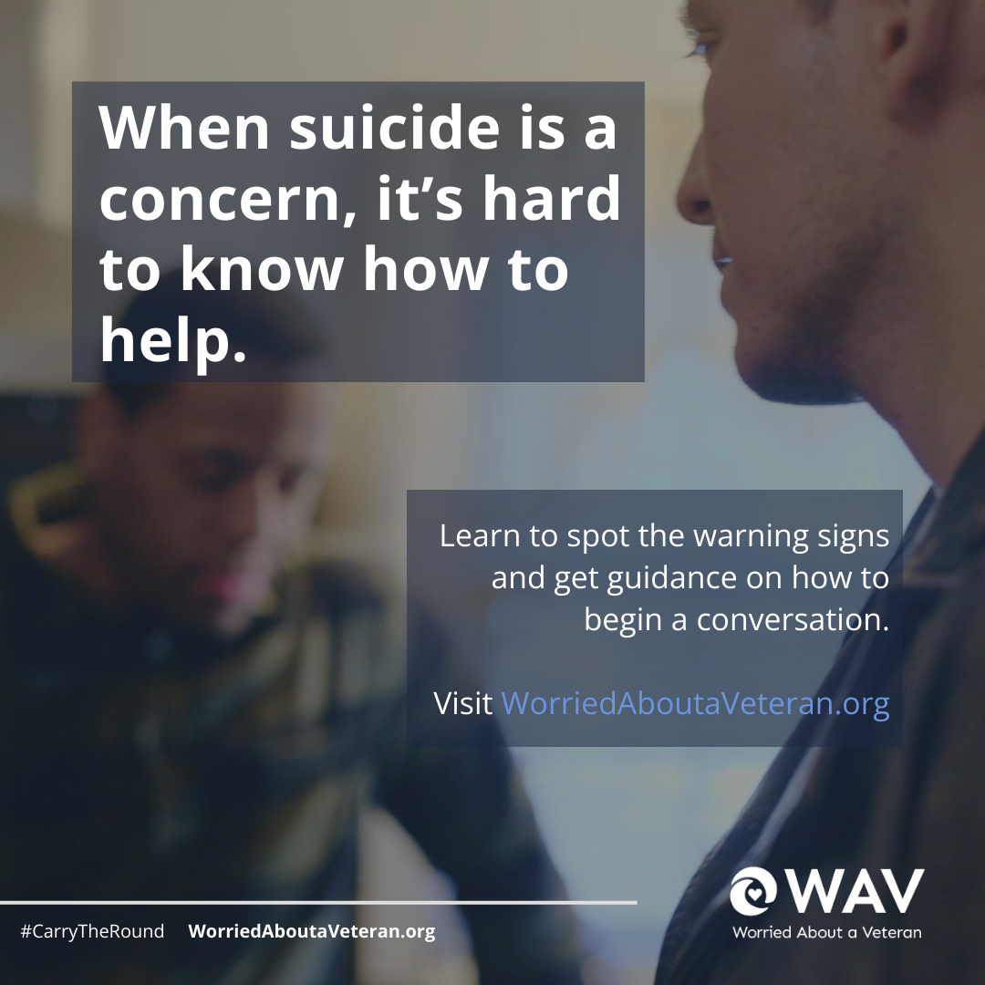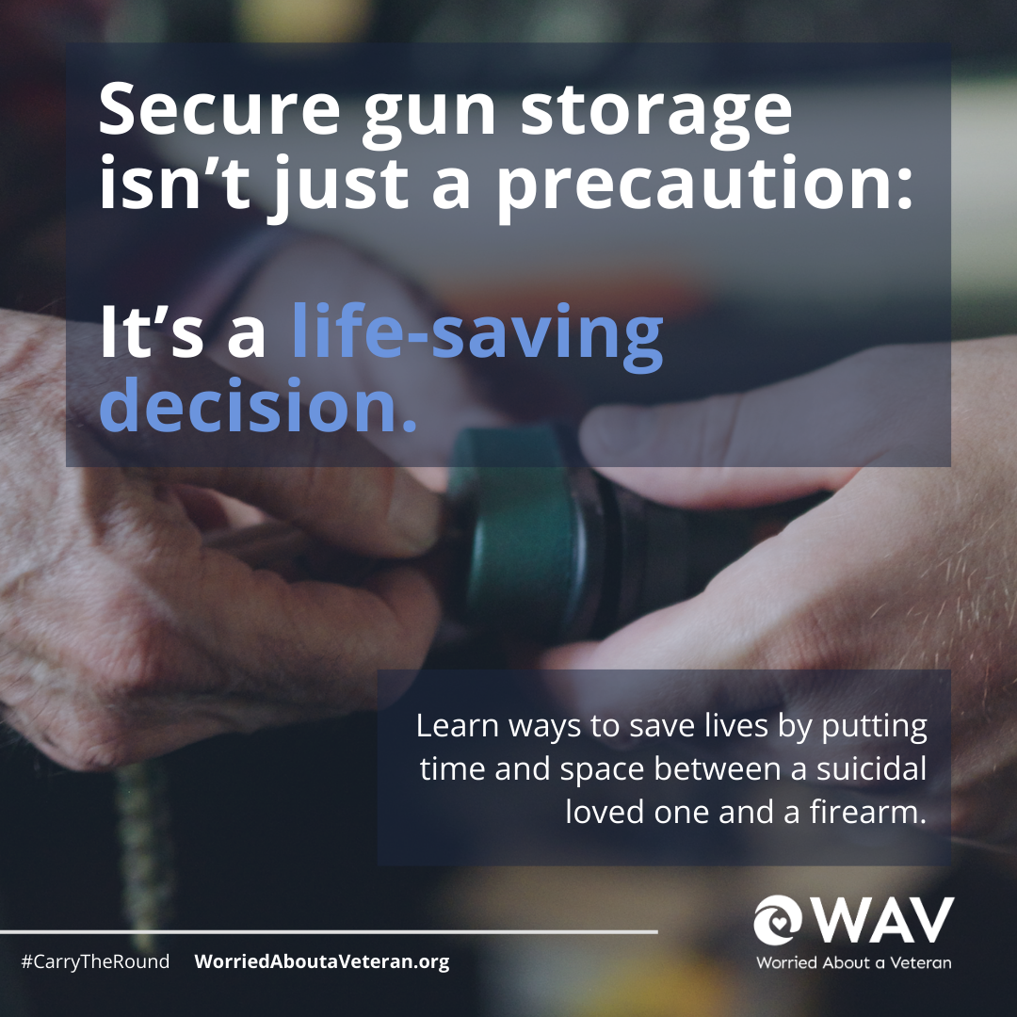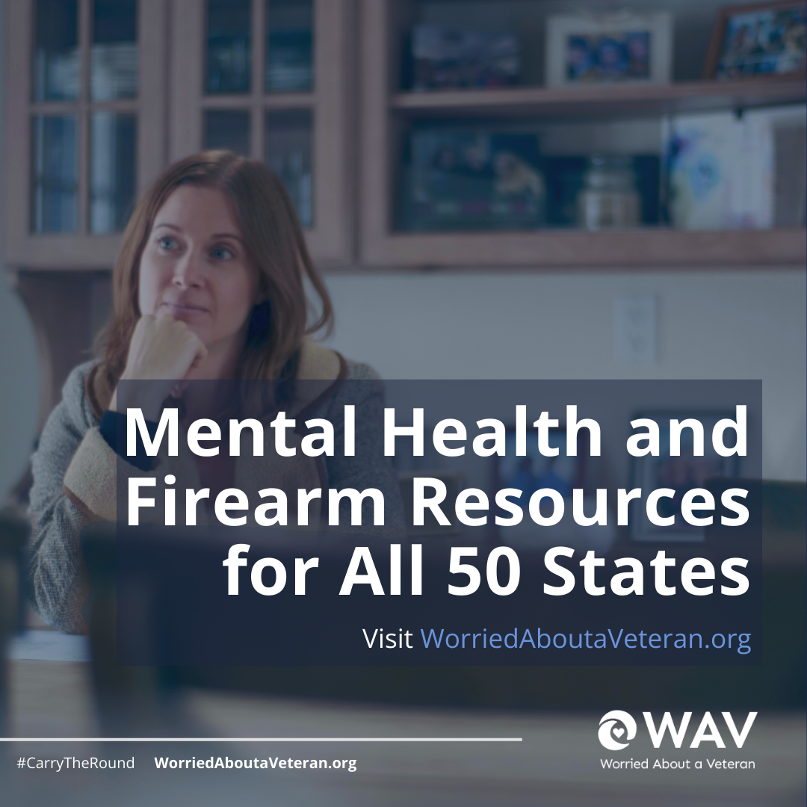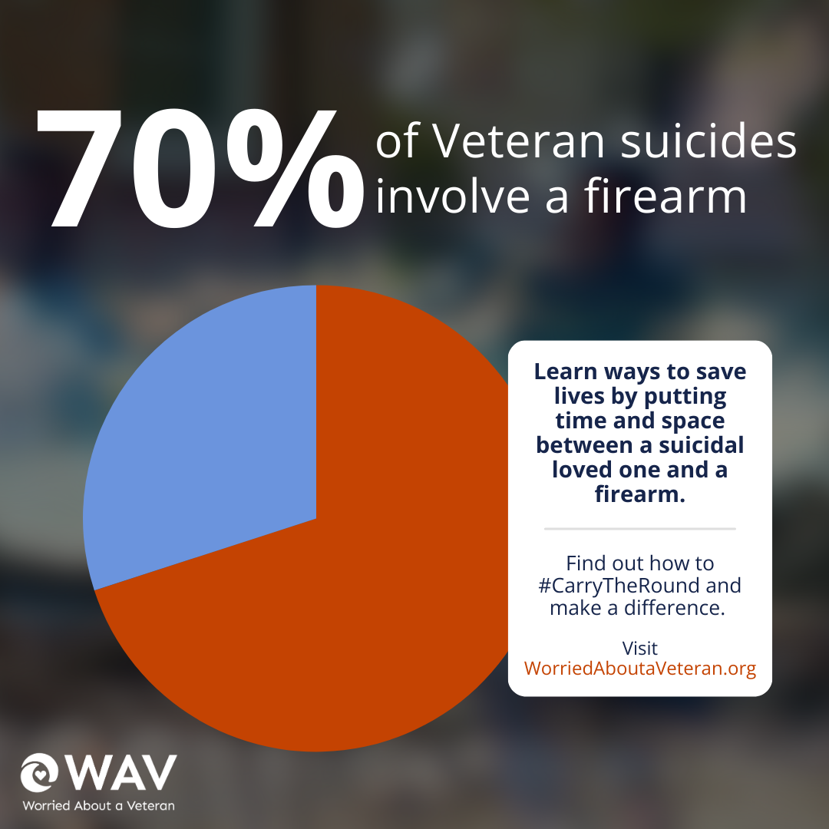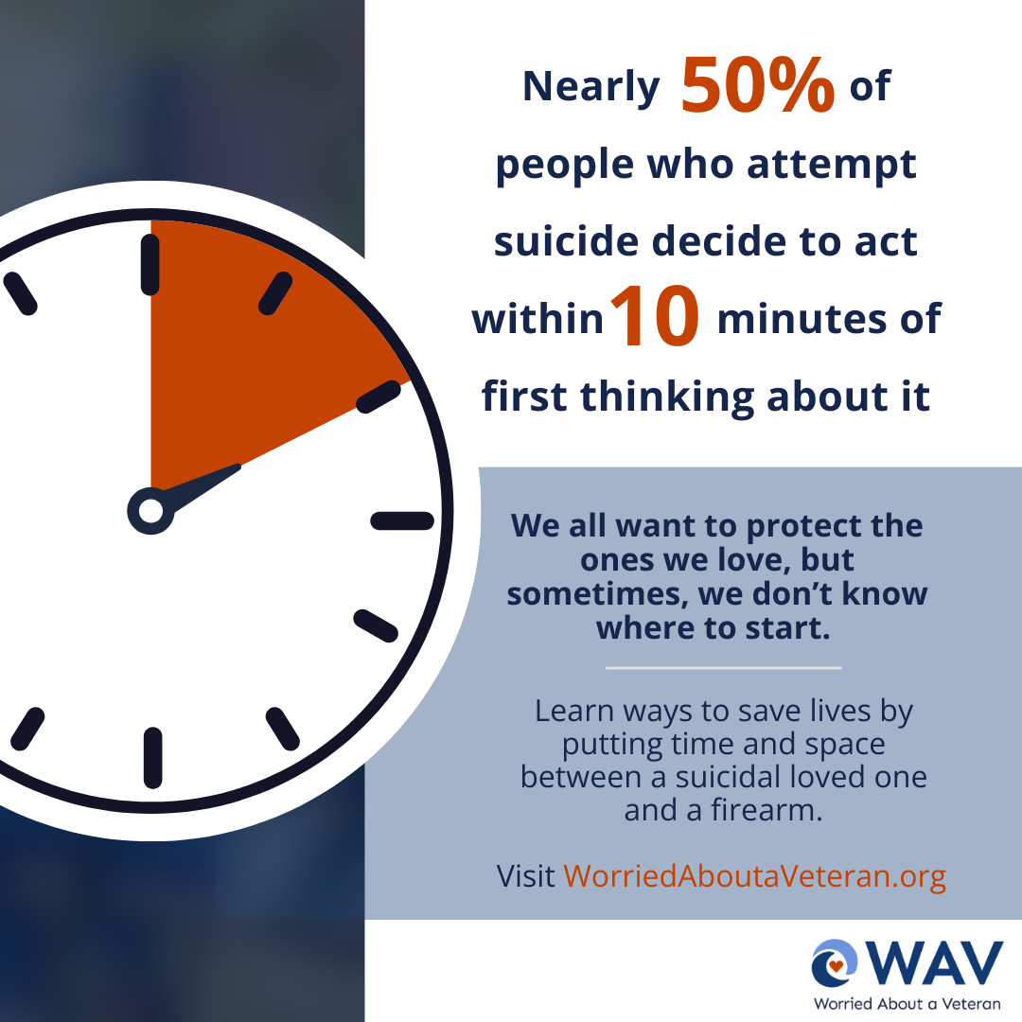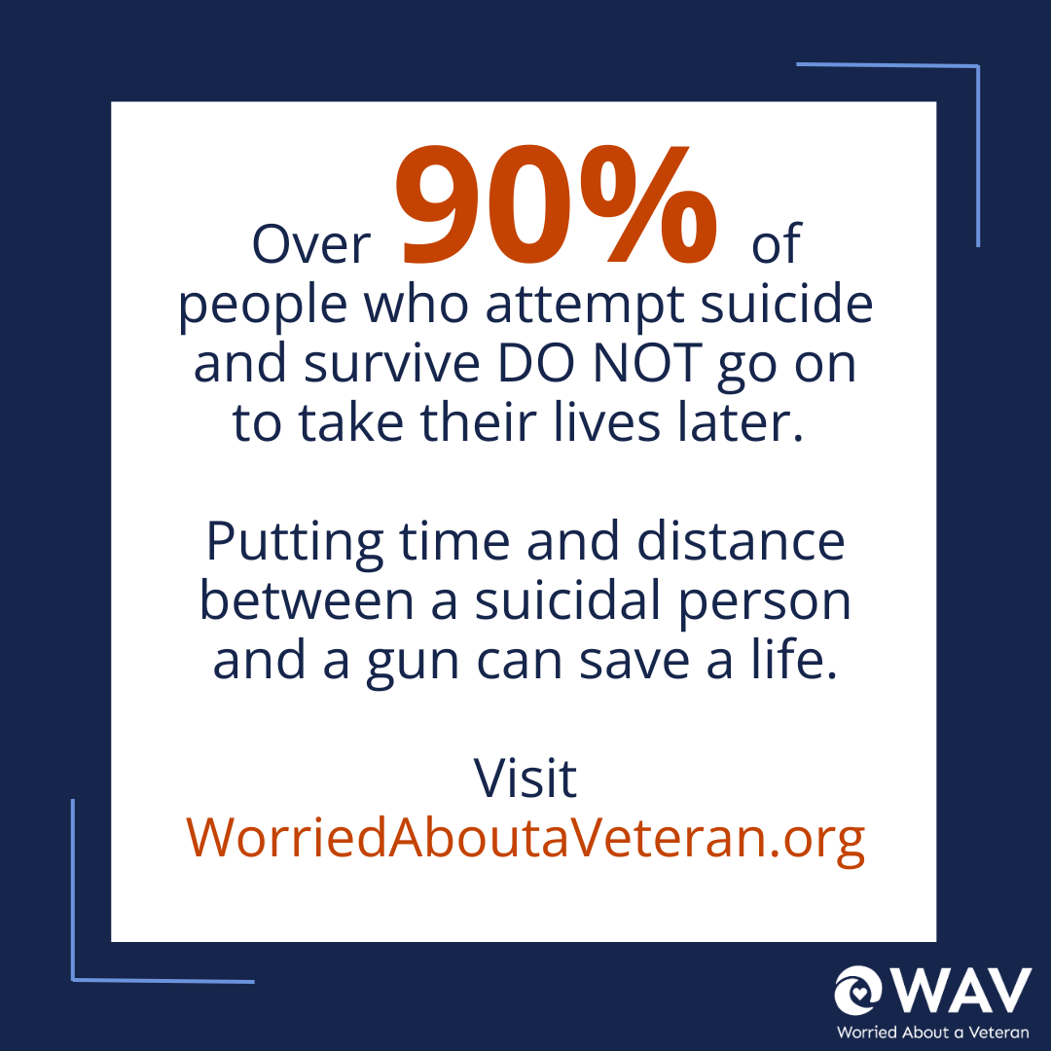
LinkedIn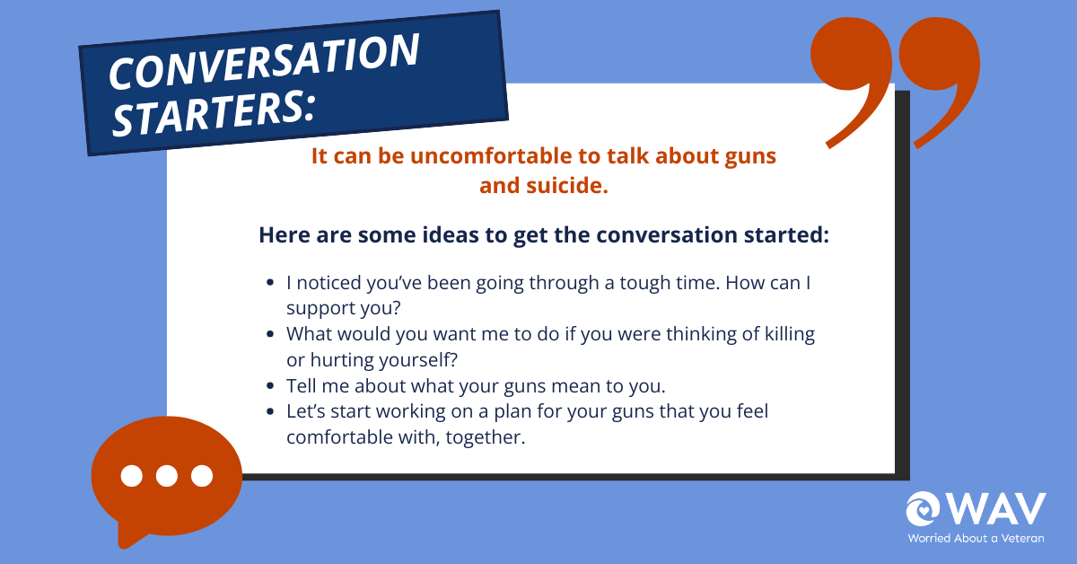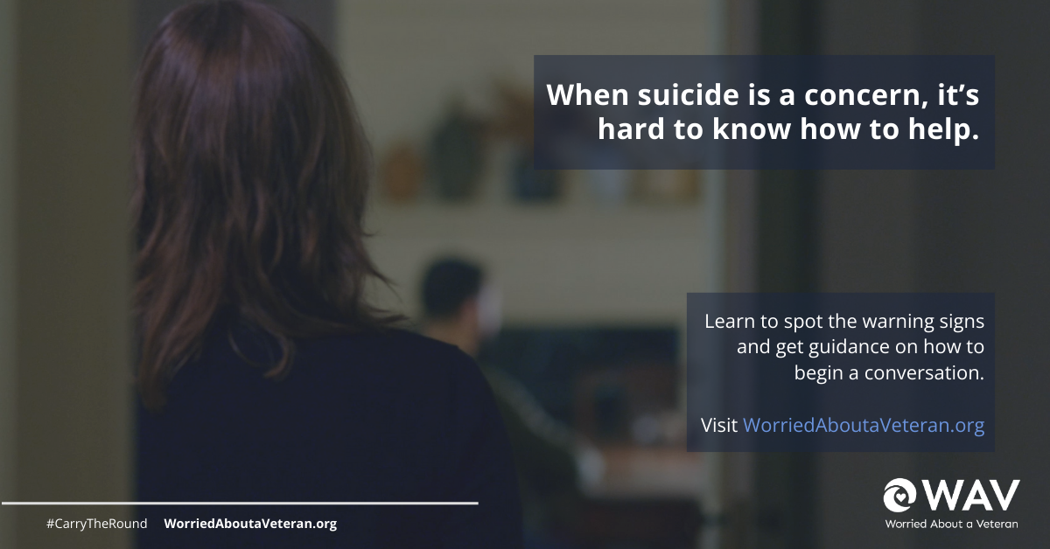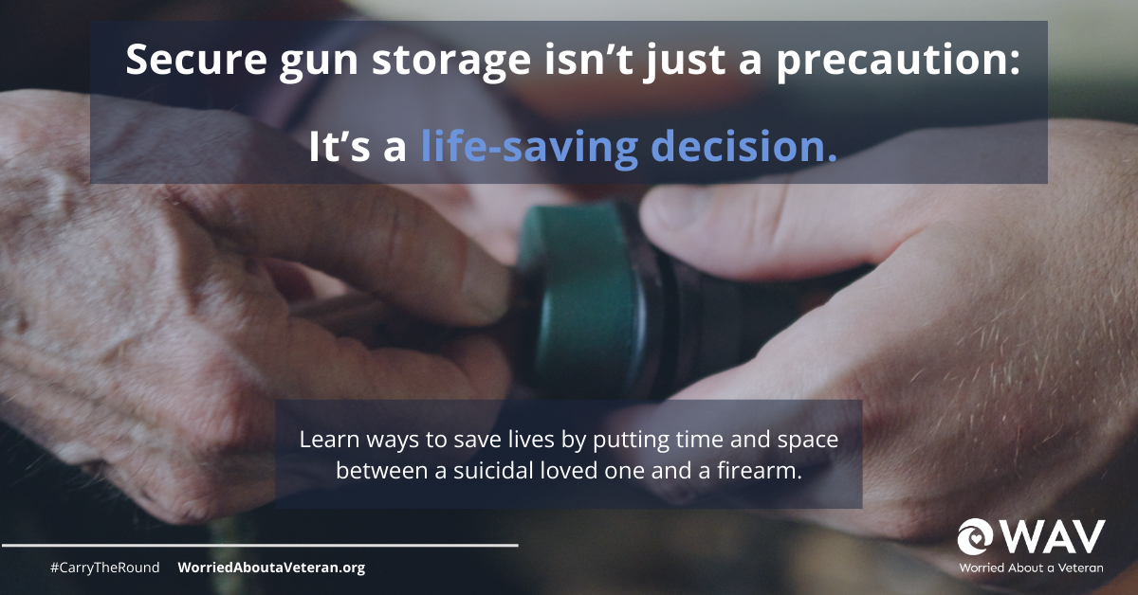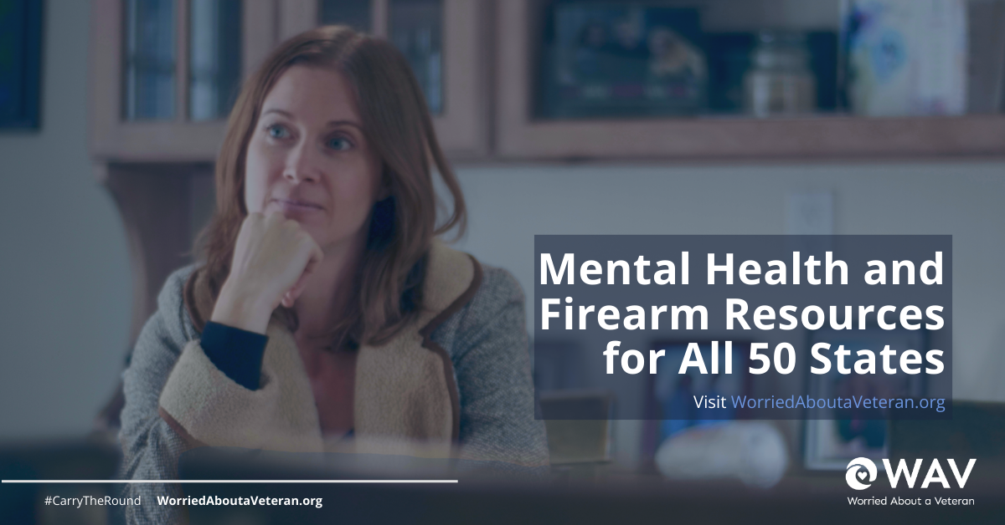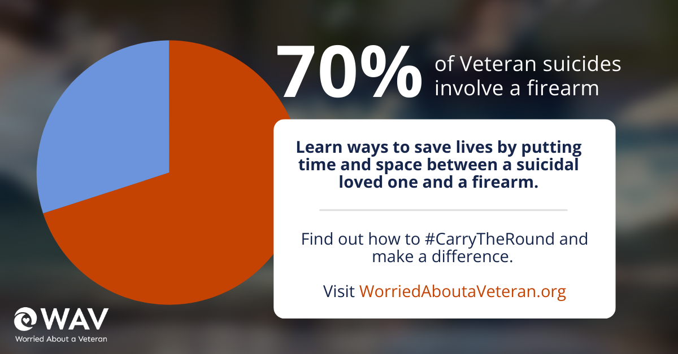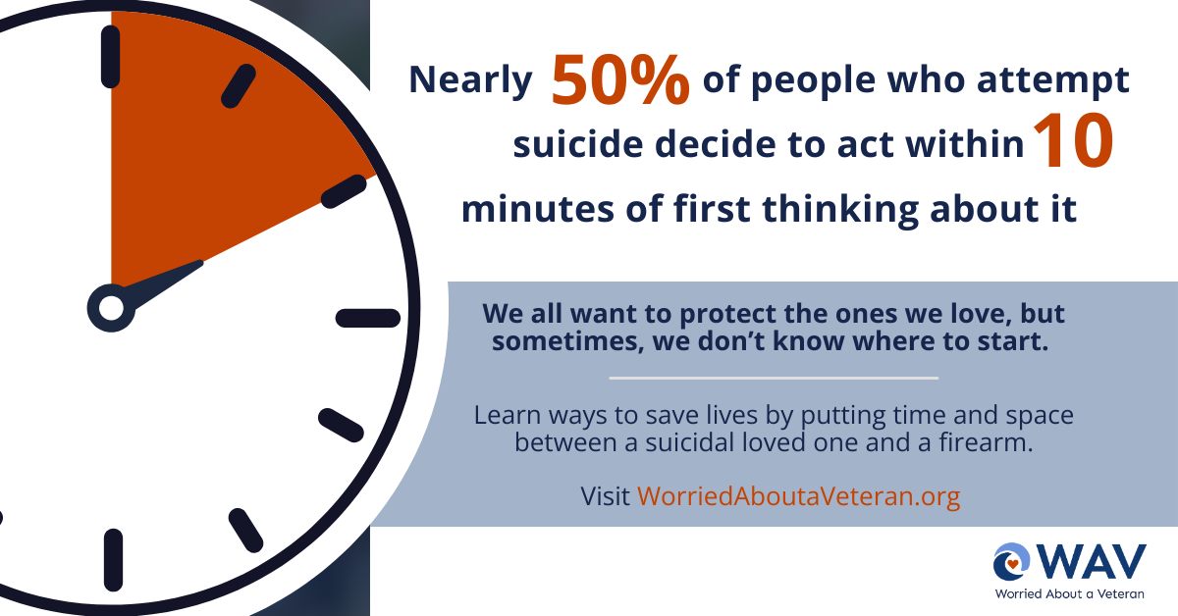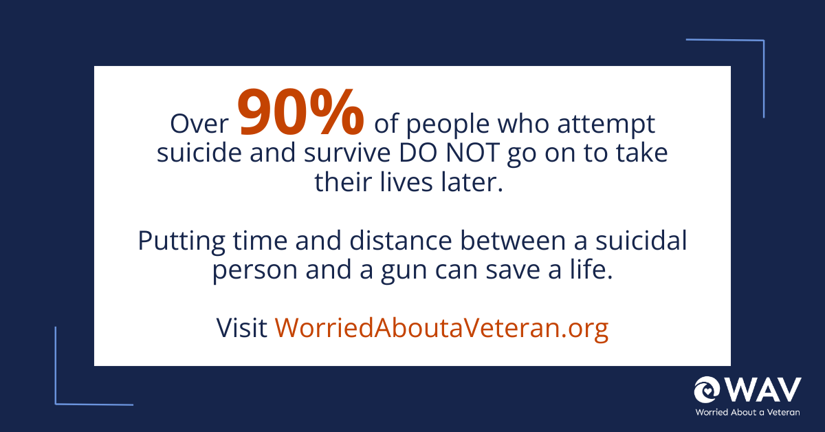

Instagram Stories/Tik Tok:
